**Supplementary Figure 2a: Phylogeny of the five bacteria *Ec*, *Kp*, *Se*, *Sa* and *Sp* constructed using *rpoB* and *rpoC* gene sequence**



Phylogeny of the five bacteria *Ec*, *Kp*, *Se*, *Sa* and *Sp* constructed using *rpoB* and *rpoC* gene sequences. The sequences were aligned using ClustalW and then the tree diagram was constructed using Maximum Likelihood Tree Algorithm in MEGAX software (Kumar et al. 2018)

**Supplementary Figure 2b: Phylogeny of *Ec* strains constructed using *rpoB* gene sequences**

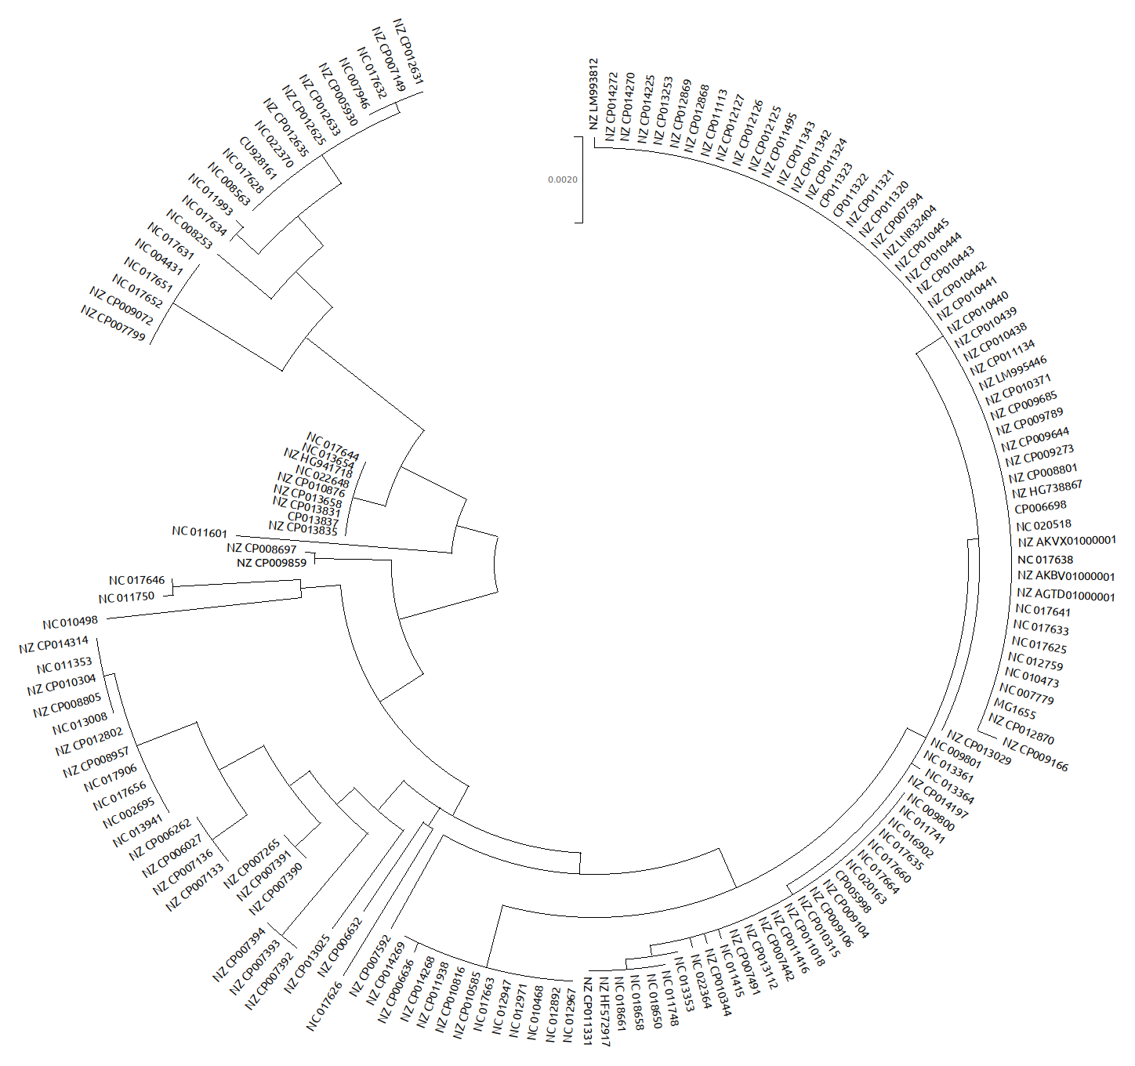

Phylogeny of 157 strains of *Ec* was constructed using *rpoB* gene sequences. The sequences were aligned using ClustalW and then the tree diagram was constructed using Maximum Likelihood Tree Algorithm in MEGAX software (Kumar et al. 2018).

**Supplementary Figure 2c: Phylogeny of *Kp* strains constructed using *rpoB* gene sequences**

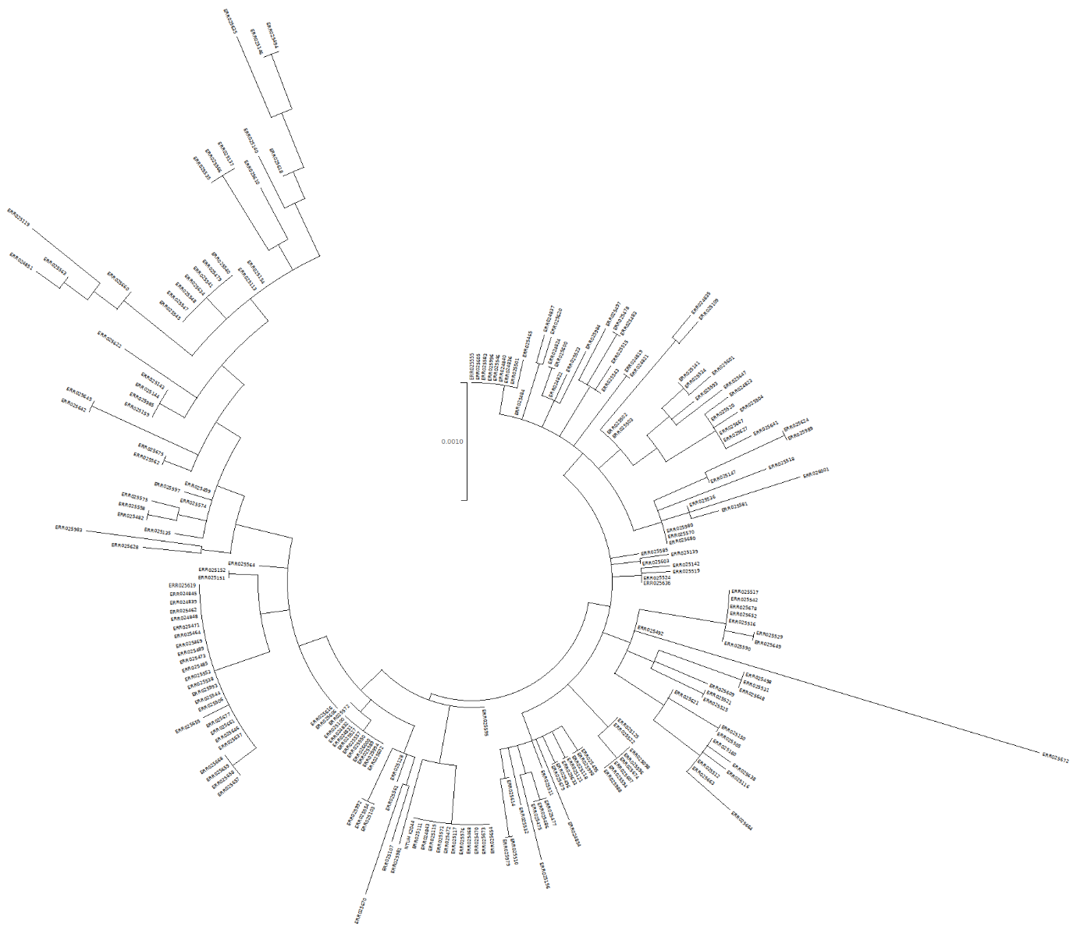

Phylogeny of 208 strains of *Kp* was constructed using *rpoB* gene sequences. The sequences were aligned using ClustalW and then the tree diagram was constructed using Maximum Likelihood Tree Algorithm in MEGAX software (Kumar et al. 2018).

**Supplementary Figure 2d: Phylogeny of *Se* strains constructed using *rpoB* gene sequences**

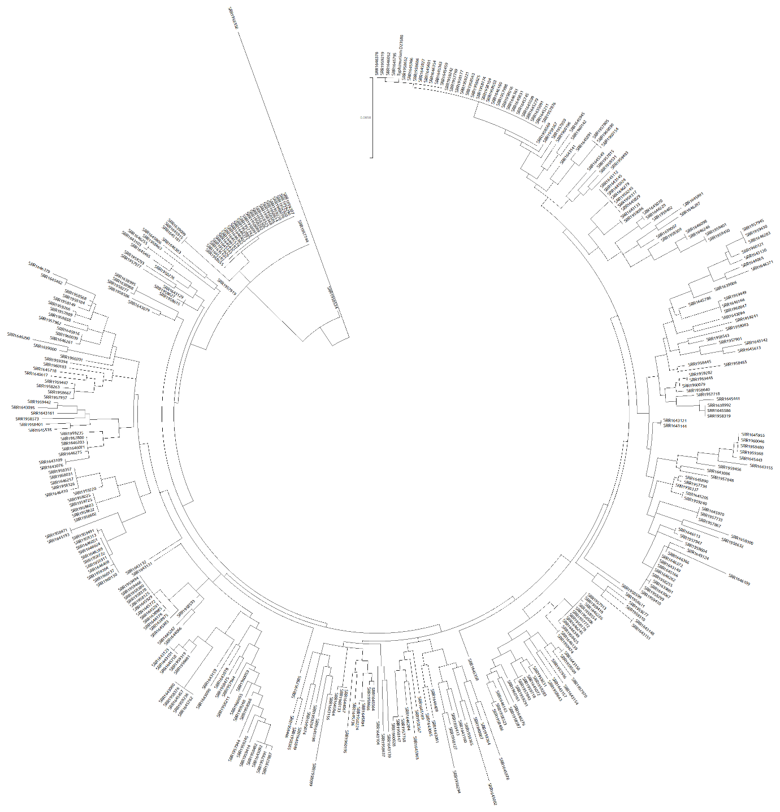

Phylogeny of 366 strains of *Se* was constructed using *rpoB* gene sequences. The sequences were aligned using ClustalW and then the tree diagram was constructed using Maximum Likelihood Tree Algorithm in MEGAX software (Kumar et al. 2018).

**Supplementary Figure 2e: Phylogeny of *Sa* strains constructed using *rpoB* gene sequences**

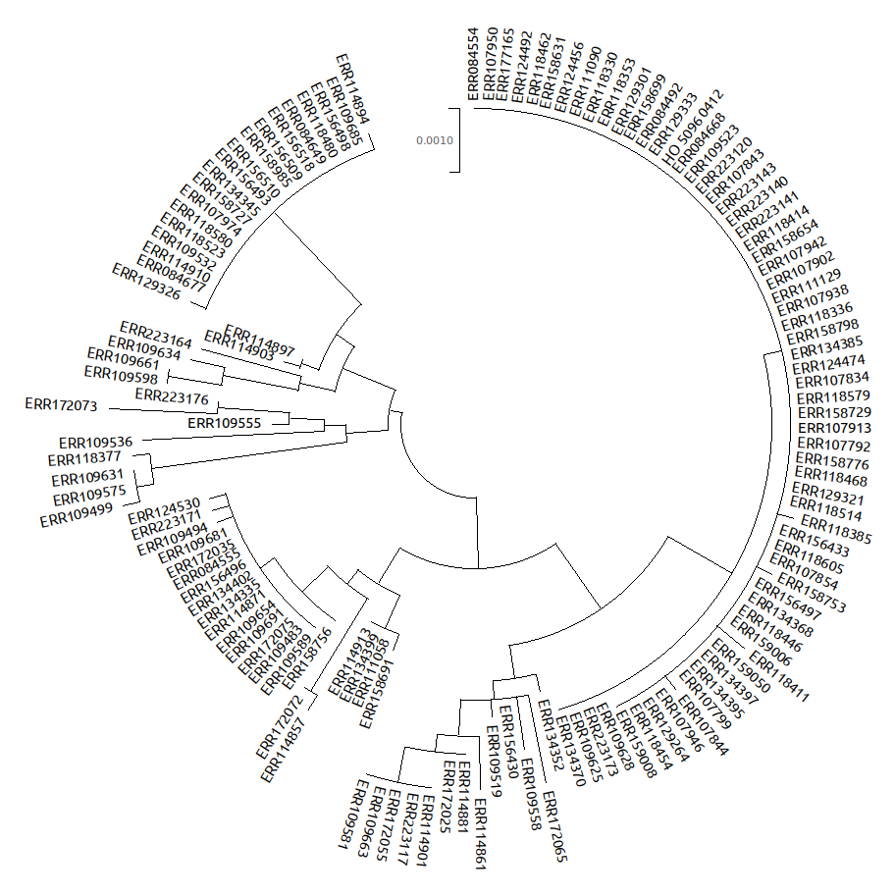

Phylogeny of 132 strains of *Sa* was constructed using *rpoB* gene sequences. The sequences were aligned using ClustalW and then the tree diagram was constructed using Maximum Likelihood Tree Algorithm in MEGAX software (Kumar et al. 2018).

**Supplementary Figure 2f: Phylogeny of *Sp* strains constructed using *rpoB* gene sequences**

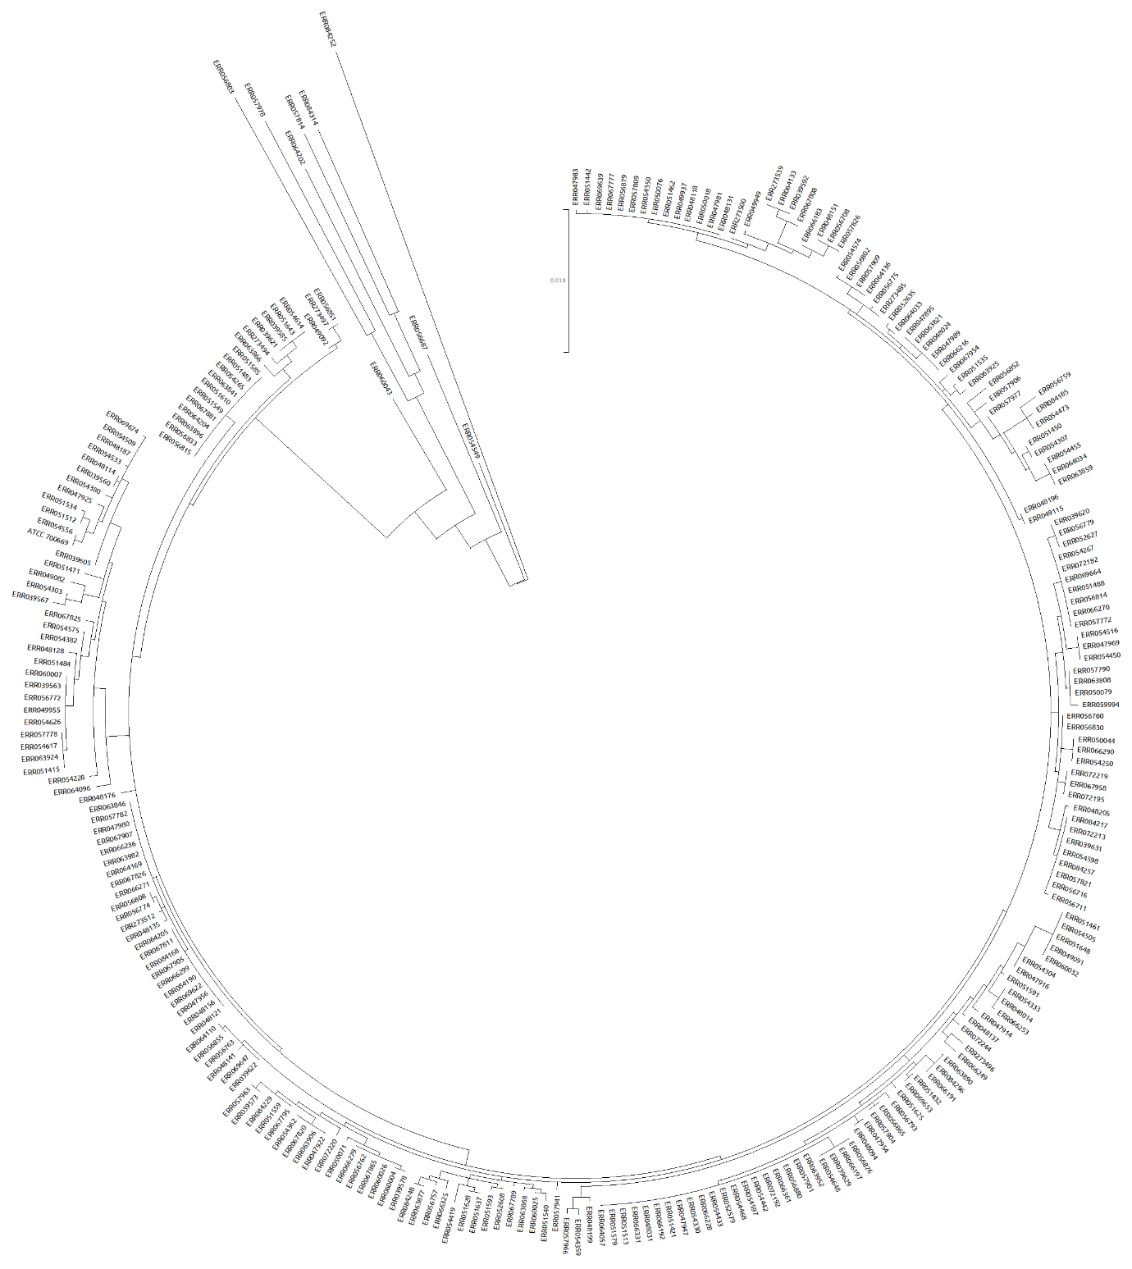

Phylogeny of 264 strains of *Sp* was constructed using *rpoB* gene sequences. The sequences were aligned using ClustalW and then the tree diagram was constructed using Maximum Likelihood Tree Algorithm in MEGAX software (Kumar et al. 2018).